Ragade’s Cube Test Plan
Chris Lockhart
Steven Shofner
Jason Spruill
Chris Boyle
Table of Contents

Building the Test Inventory 2
Test Case Generation 3
Acceptance 3
System 3
Integration 4
Component / Unit 5
Risk Analysis of Test Cases 5
Generating Test Case Priority 5
Test Effort Estimation 6
Negotiate Testing Resources 6
Track progress 6

Building the Test Inventory

The goal is to have our test inventory to contain all of the possible tests we can think of/ generate. However, Macabe’s software has given us some insight to this goal; Our program is very large. Unit testing requires that we test all public members of classes. Unit testing 713 functions lends to have greater than 713 test cases. To fully test a method, multiple test cases are usually required per function. To enumerate the number of test cases for unit testing alone would be greater than our testing period.

Component testing would involve testing 4 individual components that section the 106 classes giving an average Class/Module ratio of 26.5. If the classes were all interconnected in a complete graph:
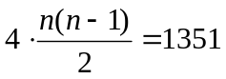
1351 links between classes for component testing. This is an overestimate as all the classes are not interconnected, but helps to give an estimate.

For Integration testing, the numbers of links become smaller and more manageable; There are 6 links between, Engine, Ragade’sCube, Input, and GUI.

System Tests verify the functionality of all our 20 Use Cases.

Acceptance tests Validate our application where our system tests have not. We have 13 Requirements in the SRS.

Now assuming that
- each link between an entity elicits only one Test Case (atypical as there will be many test cases per link)
- Each use case has at least 1 system test associated with it.
- Each Requirement has 1 test case.
Estimated # of test cases: 2097

This, again, more test cases than we could possibly enumerate in time, let alone to do the tests! This calls for major simplifications to our test plan. Being time oriented, we will focus on the most important parts, most effective, and simple tests.

Here is the simplified process for our test case generation:

Test Case Generation

We will generate our initial System test suites from our Use Cases. Use Cases reciprocate our requirements and outline everything our program should do. While the use case test cases cover most of the system tests and acceptance tests, they might miss some requirements and/or system tests. We will ensure that each is fully covered. Once the initial test cases have been defined, further detail can be added.

Our Requirements will serve as a basis for generating missed Acceptance tests. The goal is to ensure that each Requirement is tested and passed for Acceptance testing.

Integration Tests will be generated for all non application assemblages: GUI, Engine, Input. The application assembly, Ragade’sCubeGame interfacing with the dependent components is covered by system testing.

Only certain areas will receive Component and Unit Tests. Engine and GUI are too large for the time remaining. The System, Integration, and Acceptance tests will sufficiently cover and touch these areas.

Acceptance
Acceptance tests will be written to verify the requirements. In addition, we will also validate the application with client feedback. We will consider our peers as clients to direct and apply feedback to our application requirements. A general survey will be given to certain students and they will be allowed to interact with the program, they will fill out and answer questions and give feedback. Ultimately they will state whether they would accept the application.

In addition, functional Acceptance tests will be generated from the known SRS Requirements. These tests will test the application for the required functionality.

System
System tests will be generated though use case enumeration. Use cases capture sufficient system test aspects as certain key system functionality must be fulfilled for Use Case success. Use Cases will provide the foundation for our system tests, as we will generate system test cases to sufficiently test our use cases.

(See our Test Inventory for specific system tests.)

Integration

We will use a hybrid approach between Big Bang and Bottom up by testing modules in groups at once. Groups of modules will depend on other groups and therefore, certain groups will need to be tested before others. Here we will outline these groups and how we will test the links between components.

We will define the interfaces between each component in the group and test these interfaces with all modules in the group instantiated. The test cases generated will test the individual links between components in a group.

Group 1

GUI
Input
Engine

All three components are tested together. Here are the tests specific to each dependency link.

1st Test Link: GUI – Engine

- Camera Is Configured properly Test
- Font Support Test
- Pickng GUI Items Test
- Quads Appropriately configure RenderManager
- Scenes are Drawn and Updated

1st Test Link: GUI – Engine
- Gui Gets and Handles Real Input Test.

If these tests pass, we have sufficiently covered the code that links these 3 components together. However, if a test fails, it will not be truly known the exact cause of the failure. This is the tradeoff when using Big Bang style testing. We can, however, make fish bone diagrams to help conceptualize and map out the probable causes of the test failure for investigation.

Group 2

Ragade’sCubeGame
Engine
Input

These tests are sufficiently covered in the functional system tests we will perform. These tests not only test the system, but also directly verify the links between these components.

Component / Unit

In this section of testing, each module will be verified separately and independently. The module as a whole will be tested. In addition the classes of each component should be unit tested as well.
Ragade’sCubeGame –
The classes here shall be tested individually and together to verify that the module is working as expected.

Engine –
Ideally, this component will be tested fully as well. However the immense amount of classes, and interactions in this component (cyclomatic complexity) make it difficult to test. For our plan, we will treat the engine as 3rd party code. We will trust that it has been debugged during development and treat it as separate 3rd party code for that matter. Bottom line, we will not attempt to test this code as the cost is too great, this testing is ruled out by our analysis.
GUI –
While the GUI component is not as complex as Engine, the preliminary estimation for the testing effort will be too much to handle for our testing cycle. We will do the same for GUI as we are with engine.

Input –
The complexity of the input is low enough to test in time for release. Tests should test individual classes and their interactions.

Risk Analysis of Test Cases

The priority attribute of a test case is an indicator of risk for that test. The priority will define how important that the test passed to our application. All enumerated Test cases are listed and ranked by priority. This is the order that tests will be completed. This follows the MIT scheme,

Generating Test Case Priority
The Priority, we define, as a function of a test’s time cost and severity. The attributes are computed on a basis of 1-4 and averaged into a priority index. We will complete tests based on the priority Index.

The time of a test must be converted in to a number 1-4. We use a mapping table to do the look up. The severity of the test is how critical that the test passes.

Test Effort Estimation

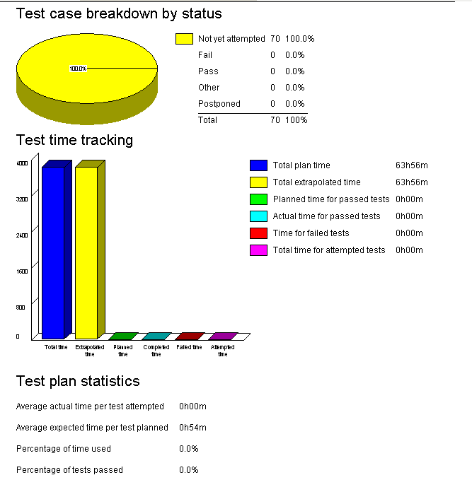

Negotiate Testing Resources

We will evenly divide the planed tests into our four group members. Also, testing surveys for acceptance tests will be handed out to ‘clients.’ Each member will be accountable for his allotted tests.

Track progress

We will use our TestLog software to track our progress. It will keep track of all sorts of status variables. In addition, it can include progress reports and estimate the time to completion based on the Bug Fix Rate. We will keep track of our progress often and produce snapshots of our status through time.

